GRA I&E Funding Program · Faculty Guide
What it is, whether your project fits, and how to apply · March 2026
What GRA I&E Funding Is, and What It Is Not
GRA's Innovation & Entrepreneurship program exists to close the translational gap, the period after a research discovery when a technology needs development, testing, or market exploration before it's ready for outside investors, industry partners, or company formation.

This is not a basic science grant. GRA funding does not support basic science, hypothesis-driven discovery, or preliminary data for NIH or NSF proposals. It supports the work that comes after the discovery: the experiments, prototypes, benchmarks, and customer conversations that ask whether a technology can become a product, company, or licensed solution.

Basic science feeds into GRA-fundable work. The question GRA asks is: has the discovery reached a stage where a specific translational milestone can be defined, and where achieving that milestone set would materially advance the technology toward commercialization?

The diagram below shows where GRA invests in the innovation pipeline. If your project is in the translational development or company formation zone, it may be a strong fit.

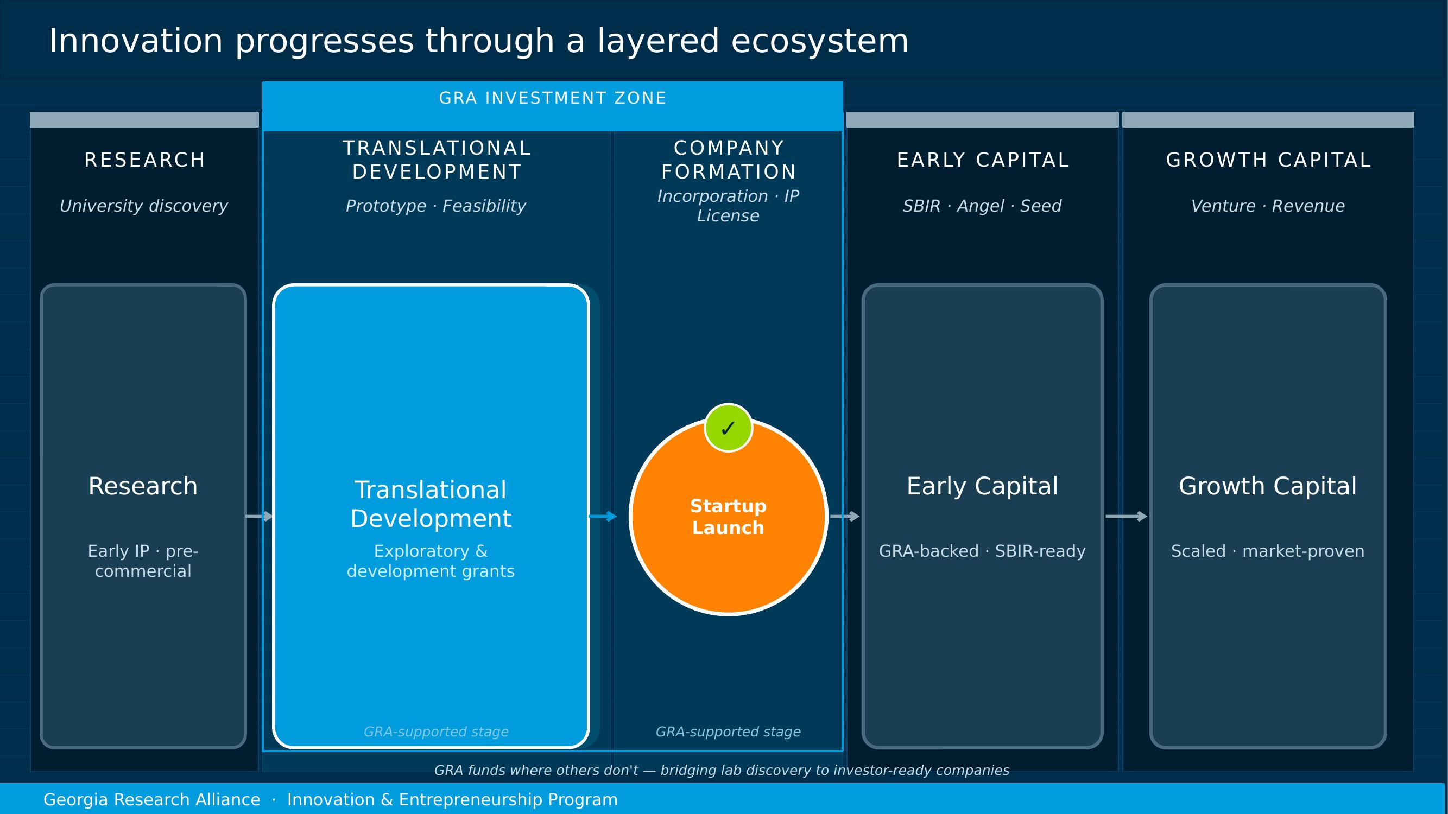
Is My Project a Fit?
Use this checklist as a starting point. If you're uncertain on any item, your university representative is the right first call. They can help you assess fit before you invest time in crafting a proposal.

Question | Yes | No / Unsure
Is my technology a Georgia university-based discovery? | ✓ | Could be a fit if new work could lead to Georgia-university-held IP
Does the technology have IP protection or an active invention disclosure? | ✓ | Talk to tech transfer before applying
Am I trying to move the technology toward a product, company, or license? | ✓ | Not the right fit. This is translational funding
Can I define specific milestones the funding would achieve? | ✓ | Not ready yet. Work with your rep to define milestones
Is the work I'm proposing distinct from my NIH/NSF research aims? | ✓ | GRA does not fund basic research or NIH/NSF preliminary data
Would the milestone results tell an investor or industry/commercial partner something meaningful? | ✓ | Proposal needs stronger commercial framing
Is my technology better, faster, cheaper, stronger than the current gold-standard? | ✓ | Proposal should be able to articulate this

GRA supports technologies across all domains: therapeutics, diagnostics, agricultural technology, software platforms, advanced materials, engineering systems, and more. The program is sector-agnostic. What matters is whether the work is aimed at real-world use.
The Two Grant Types: Which One Fits Your Project?
GRA offers two grant types. They are not necessarily sequential. You do not have to start with an Exploratory Grant. Choose based on where your project actually is, not on a prescribed path.

 | Exploratory Grant | Development Grant
Amount | Up to $10,000 | $10,000 – $250,000
Purpose | Answer a focused go/no-go question before committing to a full development effort. | Advance a technology toward commercialization or startup formation through meaningful, milestone-driven work.
Submission | Rolling submissions, reviewed as received. Decisions typically within two weeks. | 6 fixed cycles per year. Submissions accepted anytime; cutoff dates determine review timing.
Use it when... | You have a key uncertainty (technical or market) that a small, targeted experiment can resolve. | You have a clear set of milestones that will materially de-risk the project for the next investor, partner, or funding source.
Skip it when... | The project already has validated signal. Go straight to Development. | You don't yet know the key question. Start with Exploratory or clarify with your university rep first.
Note | Salary support is almost never appropriate for a $10K grant. Think: vendor purchase, reagents, customer interviews potentially at a trade show. | Budget should be driven by your milestone, not the maximum. Proposals well under $250K are common and appropriate.

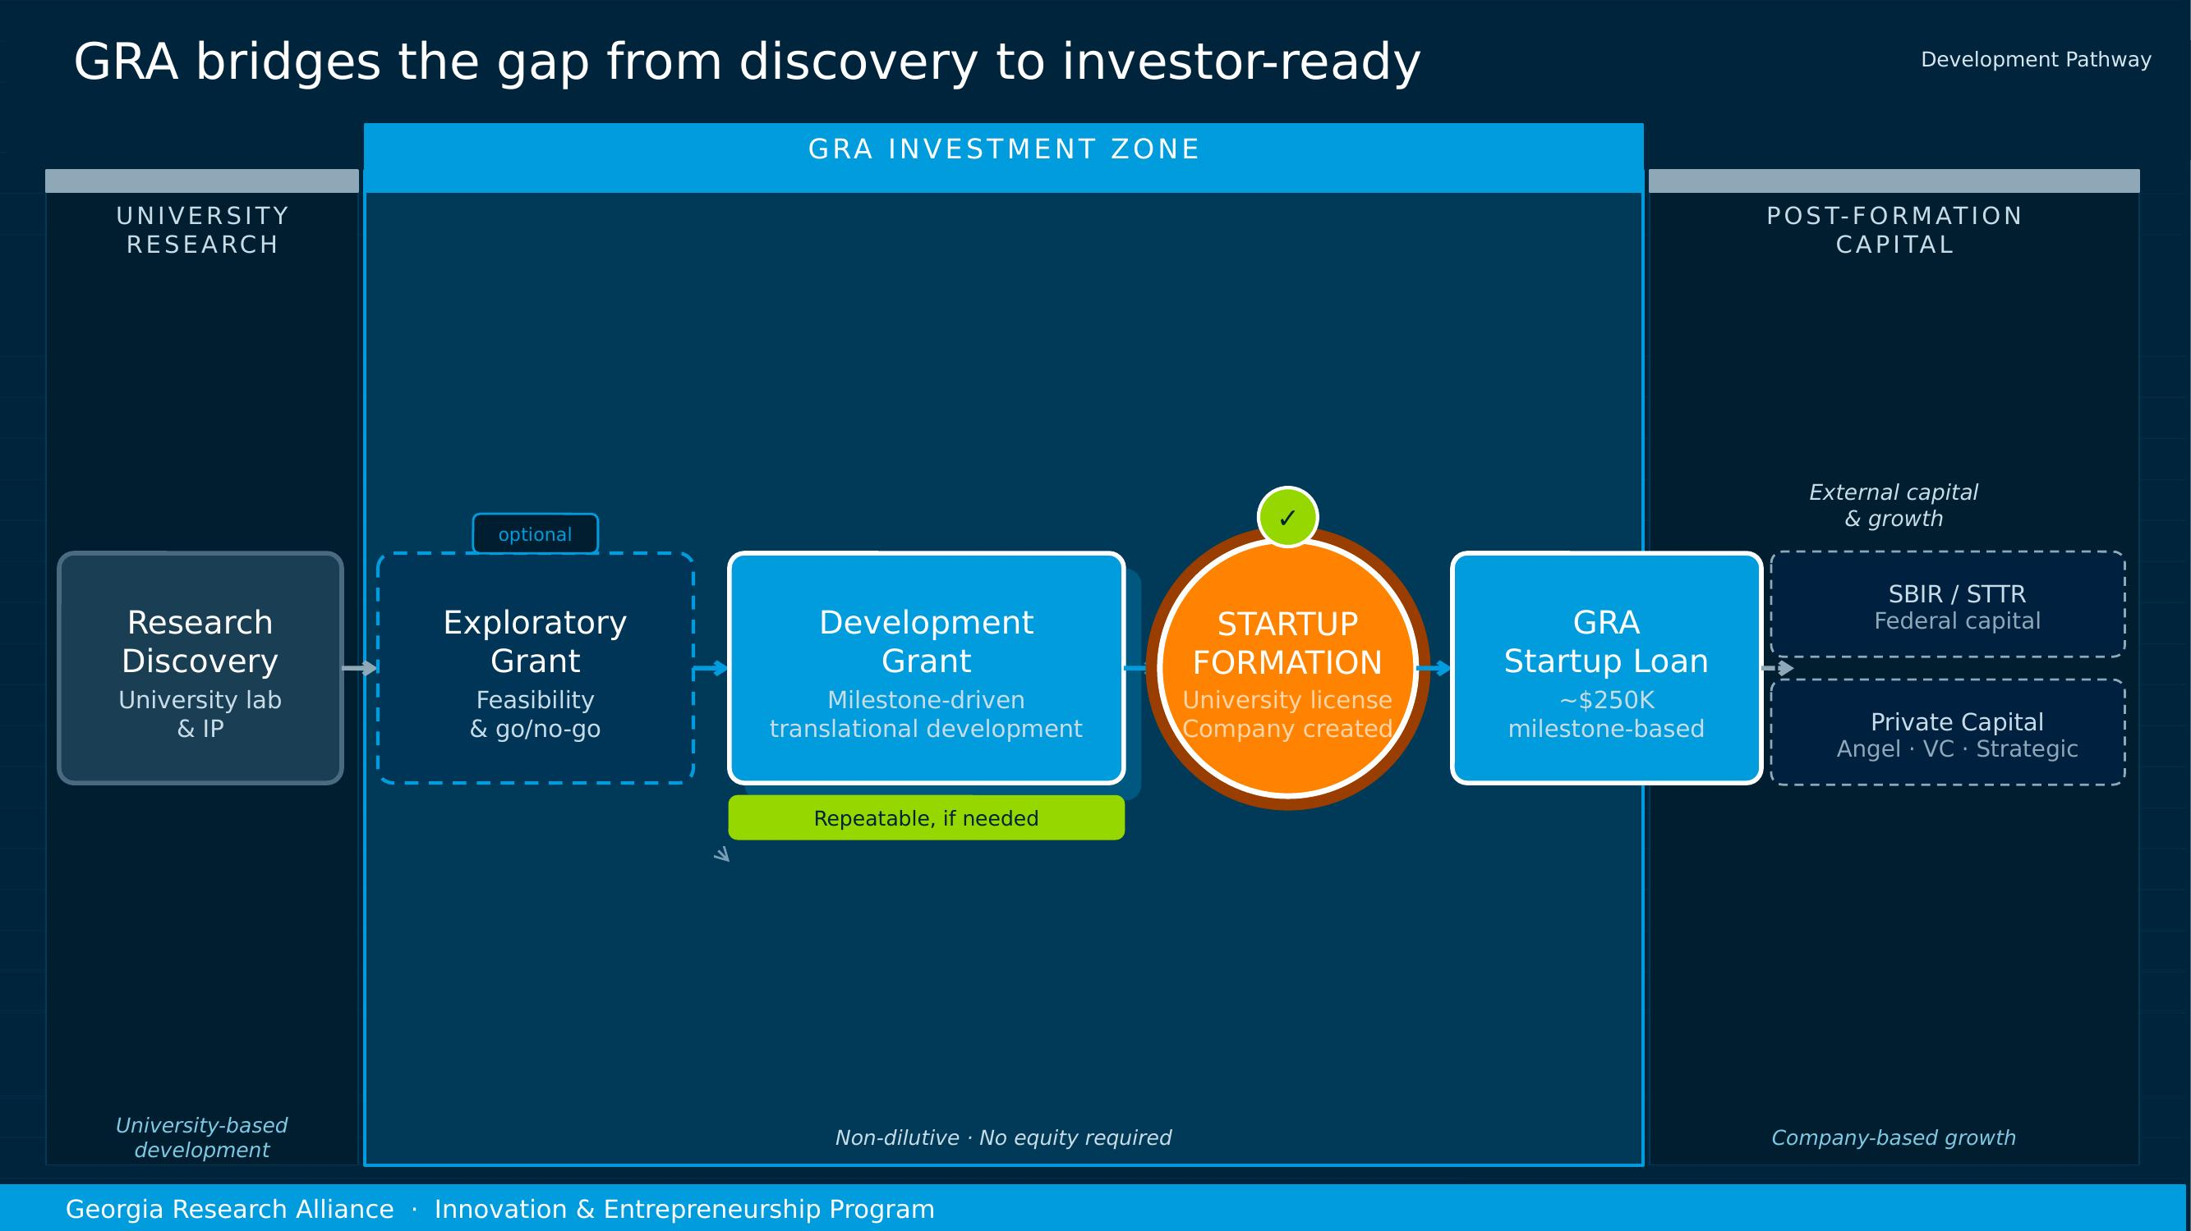

Projects may receive multiple Development Grants over time, each tied to a distinct set of meaningful milestones. There is no hard lifetime cap, but GRA evaluates whether continued investment makes sense relative to the project's progress toward outside capital or company formation.

What GRA Funding Cannot Support
Grant funds are awarded to the university and must support work that creates or enhances university-controlled intellectual property. The following uses are not permitted:

Not covered | Why
Basic or exploratory research | GRA funds translational work aimed at commercialization. Proposals designed to generate preliminary data for NIH, NSF, or DoD/DoW grants are not eligible.
Student tuition | Tuition is not a permitted use under Georgia state funding rules.
Standard lab equipment | Pipettes, centrifuges, balances, and similar items are not covered. Capital equipment (as defined by your university) is also excluded.
Patent prosecution | Legal fees for patent filing or incorporation are not permitted. Work with your tech transfer office on these costs.
Salary for equity holders | Founders, equity holders, option/warrant holders, or company employees may not be compensated from GRA grant funds. Some Universities require minimum effort on all grants from the listed PI, GRA is aware and works with universities on these specific cases.
Company operations | Marketing, branding, website development, business plan consulting, and similar company-beneficial activities are not eligible.
Academic travel | Travel solely to present research findings at conferences is not covered. Customer discovery travel or trade show interviews may be.

If you're unsure whether a specific budget item is eligible, ask your university representative before building your proposal around it. Catching this early avoids delays at review.

What Makes a Strong Proposal
GRA reviewers evaluate proposals on five dimensions. Strong proposals address all five, not just the science.

1. A clear problem and a specific solution
Who experiences this problem, and why does it matter? What does your technology do that current approaches don't? GRA isn't looking for a comprehensive literature review. It wants to understand the gap and why your solution addresses it.
2. Milestones that create a go/no-go decision(s)
The milestone set is the most important part of the proposal. Each milestone should define a specific, measurable result that a reviewer can clearly assess. Weak milestones say things like "further optimize the system" or "evaluate performance." Strong milestones say: the assay achieves ≥95% sensitivity across 100 samples compared to the current clinical standard.
3. Evidence of comparative advantage
GRA reviewers look for proposals that show, or plan to generate evidence showing, that the technology outperforms existing solutions. You don't need the data yet, but the milestones should be designed to produce that comparison. A head-to-head experiment, a benchmarking study, a validated cost model: these make proposals fundable.
4. A realistic, right-sized budget
Your budget should reflect what the milestones actually require, not the maximum allowable amount. A $30,000 proposal for a focused experiment is often stronger than a $250,000 proposal for a broad scope. Every budget line should connect directly to the milestones.
5. A credible path forward
If the milestones succeed, what happens next? A subsequent Development Grant, an SBIR application, a startup formation, an industry conversation? GRA invests in projects with a plausible onward trajectory, with forward looking vision. GRA funding shouldn’t be the end of the road.

The proposal template includes inline examples of strong and weak milestone language. Read those before writing your milestones. They may save you a revision cycle.
The Application Process
Who submits the proposal?
Proposals must be submitted by your university representative, not directly by the PI. This is by design. Your rep is GRA's partner on the ground and plays an active role in shaping proposals before they reach review. Reach out to your rep first.
When can I submit?
Exploratory Grants are accepted on a rolling basis and reviewed as they arrive. Development Grant submissions are also accepted at any time, but they enter formal review at the next cycle cutoff. There are six cycles per year. The diagram below shows the annual schedule.

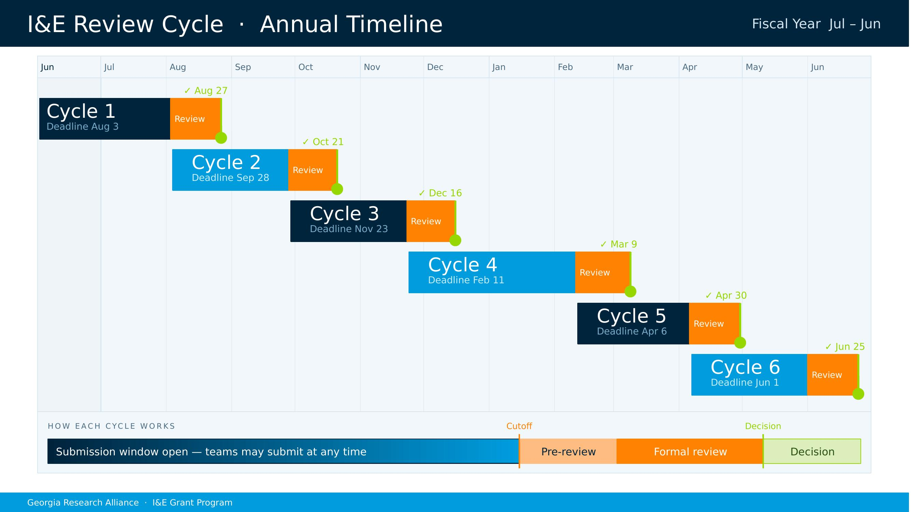
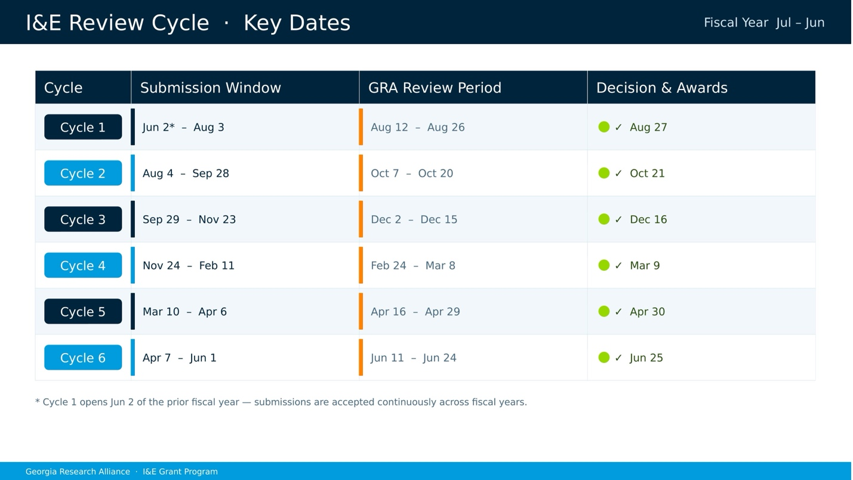
How long does review take?
Development Grant decisions are targeted within approximately four weeks of the cycle cutoff. Exploratory Grants are reviewed as received, typically within two weeks. GRA will flag any missing items (a missing vendor quote, an incomplete section) before the cutoff, giving your team time to resolve them.
What feedback will I receive?
All proposals receive feedback, whether funded or not. GRA's goal is for every team to understand what would strengthen their proposal so that a rejection is the beginning of a better submission, not the end of the conversation.
Can I submit again after a rejection?
Potentially. For some projects, a rejection is not a permanent no: If the feedback points to fixable issues such as a clearer milestone set, a comparative benchmark, or a tighter scope, you can revise and resubmit in a future cycle. Some projects do not demonstrate a clear unmet need or the technology does not significantly improve on the market standard. The feedback will outline these cases and the project is not a fit for resubmission.
What if my project pivots mid-grant?
Tell GRA. If the development merits a move into a new direction, GRA would rather know early than find out at the six-month progress report. Pivots are normal and the program is designed to accommodate them. Prior approval is required for changes to scope, budget, or timeline.
What happens after funding?
You'll submit progress updates every six months while the grant is active. GRA may also connect funded teams with investors, SBIR advisors, and industry contacts, particularly as milestones are achieved and the project approaches company formation or external capital. The goal is not just to fund the work but to help it reach the next stage. You are welcome to contact GRA or your university rep at any time during an active grant, and we encourage updates as projects develop.

Your First Step: Talk to Your University Representative
Your university representative is the right starting point, before you open a template, before you scope a budget, and especially if you are not sure whether GRA is the right fit for your project.

Your rep can help you:
- Assess whether your project is at the right stage for GRA funding
- Identify whether an Exploratory or Development Grant is more appropriate
- Sharpen your milestone language before you invest time in a full proposal
- Flag IP or licensing questions that need to be resolved before submission
- Connect you with GRA staff directly if there's something that needs a conversation

University representatives by institution:

University | Representative | Contact
Augusta University | Michael Moore, Ph.D. | 706.721.4055  mike.moore@augusta.edu
Emory University | Patrick Reynolds, Ph.D. | 404.727.2211  patrick.reynolds@emory.edu
Georgia Southern University | Dominique Halaby, D.P.A. | 912.478.2733  dhalaby@georgiasouthern.edu
Georgia State University | Joanne Mitchell, Ph.D. | 404.413.6687  jmitchell152@gsu.edu
Georgia Tech | Jon Goldman | 404.915.4880  jongoldman@gatech.edu
Kennesaw State University | Chris Cornelison, Ph.D. | 470.578.5115  Ccornel5@kennesaw.edu
Mercer University | Wayne Glasgow, Ph.D. | 478.301.2024  glasgow_wc@mercer.edu
Morehouse School of Medicine | James W. Lillard, Ph.D., M.B.A. | 404.752.1863  jlillard@msm.edu
University of Georgia | Dan Geller, Ph.D. | 706.583.0876  dgeller@uga.edu

Researchers at Clark Atlanta University, Georgia College, or other accredited Georgia institutions not listed above should contact GRA at Grants@GRA.org.

GRA is available for early conversations. If you are working on something promising and want to understand whether it fits before committing to a proposal, reach out. We would rather talk now than review something that is not ready.

Questions? Email: Grants@GRA.org · Visit GRA.org to find your university representative

